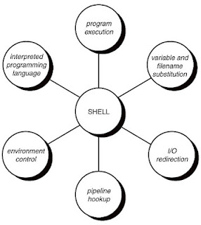
AI Command Shell

a command shell, or an extension to existing shell like BASH that analyzes your command history and automatically suggests macros that cover frequently used command patterns.

for example, if i end up typing commands like:

find | fgrep '.c'
find | fgrep 'y'

it would suggest or create a new macro:

find_p_fgrep $x

then allow me to rename it to a more convenient name like 'findit'

this could also work across a network, pooling everyone's most frequently used commands to generate a dictionary of macros that everyone can benefit from.

Prior Work

The Learning Shell: Automated Macro Construction
http://www.springerlink.com/content/ed2rpwv7f64tfykq/
By analysing sequences of actions performed by a user, one can find frequent subsequences that can be suggested as macro (script) definitions. However, often these 'actions' have additional features. In this paper we combine an algorithm to detect frequent subsequences with an inductive logic programming system to automatically generate for each frequent subsequence the most specific 'template' for these additional features that is consistent with the observed frequent subsequences. The resulting system is implemented and used in an application where we automatically generate macros from logs of the use of a Unix command shell.

http://en.wikipedia.org/wiki/Information_integration
http://en.wikipedia.org/wiki/Data_deduplication
In computing, data deduplication is a specialized data compressiontechnique for eliminating coarse-grained redundant data. The technique is used to improve storage utilization and can also be applied to network data transfers to reduce the number of bytes that must be sent across a link. In the deduplication process, unique chunks of data, or byte patterns, are identified and stored during a process of analysis. As the analysis continues, other chunks are compared to the stored copy and whenever a match occurs, the redundant chunk is replaced with a small reference that points to the stored chunk. Given that the same byte pattern may occur dozens, hundreds, or even thousands of times (the match frequency is dependent on the chunk size), the amount of data that must be stored or transferred can be greatly reduced.

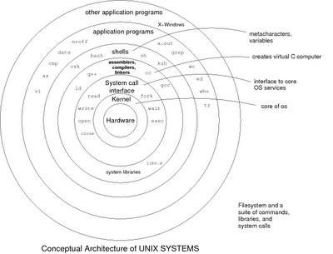

That's an interesting idea. One problem might be ending up with more macros than you can remember. Another approach might be auto-complete by comparing what you are typing with commands you entered previously.

In either case, it's similar to the problem of compressing your command history.

-- Matt Mahoney

Absolutely, command auto-completion suggestions could certainly be involved.

i certainly recognize the relevant application of compression and also the inductive logic solution applied in the mentioned paper.

On Thu, May 17, 2012 at 3:53 PM, james northrup wrote:
training against strace dumps of any program, shell or otherwise would be trivial to provide for a stream of entity actions to classify

Example ltrace output:

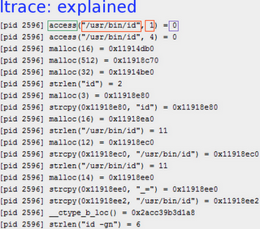
ltrace explained

yes! i think the strace or ltrace traces for a given command could indicate:
- variations in called functions and their parameters resulting from similar commands
- other possible sequences and combinations of traces that could produce novel programs
- identifying different commands that produce the same result (share similar trace segments, especially towards the "center" of a program's execution)

i guess it's possible to form a kernel that contains the ltrace results of shell commands executed from an ever-growing networked distributed shell log. it would be compressible since it would be exposed to many similar sequences of command characters and their resulting ltrace function calls.

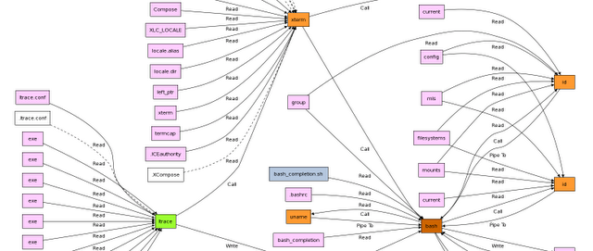
From: http://ellexus.wordpress.com/2011/11/23/getting-started-with-ltrace-how-does-it-do-that/

what would the advantages of such a kernel be?

- could it optimize the system (for memory or speed) as a whole in a way that the current unix system architecture hasn't allowed us to consider?
- could it develop into a more natural (as in NLP) command shell by mapping semantics to dynamic shell macros? this would gradually eliminate the need for a lot of programmed software in non-natural computer languages like sh, python, c++, java, javascript, etc...
- what kinds of new software could it "evolve" from the "ecosystem" of program fragments that are "learned" by the AI shell?
- could it learn arbitrary natural language commands for interacting with social networks, and Mailpool itself?

jim has suggested using a C++ compiler to dynamically recompile a high-performance knowledgebase module for this and other projects. unless i'm mistaken, i think this could result in the fastest read-only KB (for our modern commodity CPU architecture, atleast). does it provide any other advantages?

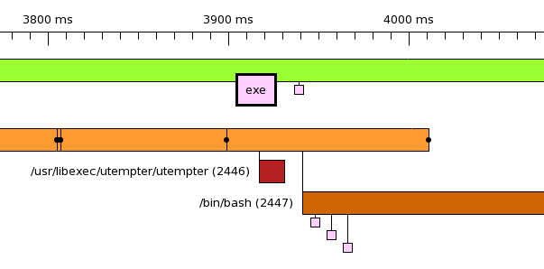
From: http://ellexus.wordpress.com/2011/11/23/getting-started-with-ltrace-how-does-it-do-that/

the same way that the AI command shell can learn to associate commands with ltrace's, an AI file system could learn to associate file names with their content. then it could be used to predict possibilities of what the file might contain based on the filename / path

it could be isolated to certain subtrees of the FS,
but anyway it wouldnt be invoked for ordinary file access. it would be a background indexing process that adds the ability to guess what a file might contain if it existed. anyway i think the same associator for AI command shell could be applied to files because its reduces to querying the AI command shell:

what_may_happen_if cat $filename

and similarly:

what_happens_if curl $url

clean pages subsystem might be more generic

what you need is to link up with the linux kernel namespaces, manage clean page cache, and then perform bayes shit on the actual buffer caches, fs-agnostic. report back to ai command shell

Anonymous Industry Insider: do yourself a favor and configure/build a linux kernel. it far exceeds the expectations and efficiency of competing intelligent agent shells
(03:52:49 PM) seh999@gmail.com/222049FA: ?
(03:52:53 PM) seh999@gmail.com/222049FA: i've configured linux kernels back in the day
(03:53:04 PM) seh999@gmail.com/222049FA: but eventually distros became stable enough that i just trusted the included stock kernel
(03:53:39 PM) seh999@gmail.com/222049FA: and its modules
Anonymous Industry Insider: i actually run gentoo because ubuntu was accruing errors waay too quickly but now i spend most sundays reading new kernel updates
(03:54:55 PM) seh999@gmail.com/222049FA: the goal of the agent shell wouldnt necessarily be efficiency at all
(03:55:04 PM) seh999@gmail.com/222049FA: at least at first
Anonymous Industry Insider: at the end of the day it does do everything though
(03:55:36 PM) seh999@gmail.com/222049FA: it could have many goals but the first step is just to see if it can discern patterns in ltraces or at least just the output
Anonymous Industry Insider: it just doesn't explicitly implement use cases
(03:56:04 PM) seh999@gmail.com/222049FA: i dont see the connection to the linux kernel though
(03:56:19 PM) seh999@gmail.com/222049FA: in building a linux kernel, the configuration is the input and the binary is the output
(03:56:21 PM) seh999@gmail.com/222049FA: like a makefile
Anonymous Industry Insider: no i just mean the wiring and sensor input you need are already well ingrained kernel features, and the fs subsystem is fine for data aquisition via the schedulers and namespaces
(03:58:02 PM) seh999@gmail.com/222049FA: yeah totally
Anonymous Industry Insider: you are missing out on interesting kernel modules being mainlined
(03:58:08 PM) seh999@gmail.com/222049FA: lots of stuff to mine, even in /proc
Anonymous Industry Insider: device drivers are boring but there's a brainfuck schedular in the older mm kernels and a LOT of normalization and unification work is happening in the page cache subsystems now
Anonymous Industry Insider: and there are block abstractions for everything anyways

Updates - June 2013
NuPIC (Prediction Framework)
https://github.com/numenta/nupic/wiki

Markov Chain
Symbolic Sequence Probabilities

Esprima (Javascript Parser)
http://esprima.org/index.html

Portable Unix shell commands for Node.js
http://shelljs.org
https://github.com/arturadib/shelljs
http://documentup.com/arturadib/shelljs

Node.JS Tab Completion
http://stackoverflow.com/questions/7096772/how-do-i-implement-tab-completion-in-node-js-shell
Exterminate (HTML Terminal Emulator / HTTP server)
https://npmjs.org/package/exterminate

UI agnostic command shell
https://npmjs.org/package/shotgun

Implementation

FEATURES
- supports multiple syntaxes: bash, javascript, etc
- context aware (ex: my linux PC, and android, etc…) and allows switching between them
- input -> output database can be used to predict certain parts of the output
  - for each instance of command
    - record time/cycles required
    - record when command executed
    - record time since previous command executed
    - previous/next command
- post-execution explanation of a command
  - create an alias function
    - identify parameterizable tokens/symbols (requires lexer for current script)
  - set to expect certain tokens as output; unexpeccted tokens are excluded from exact pattern matching=
- suggests commonly executed command sequences that can be batched into a new function (name chosen when prompted for one)
- hopfield or markov chain network to identify common sequences and co-occurence of commands

NODE.JS IMPLEMENTATION
- node.js web application, utilizing HTML5/JS for a rich graphical user interface
- mongodb and/or levelgraph

